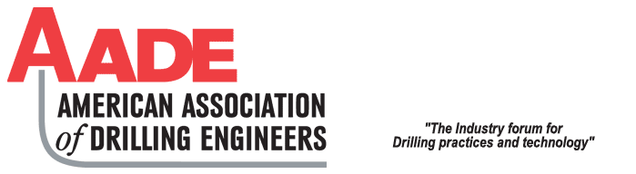

AMERICAN ASSOCIATION OF DRILLING ENGINEERS

APPALACHIAN CHAPTER
2025-2026

SCHOLARSHIP PROCEDURES AND GUIDELINES

Purpose of Scholarship:

Five $2,000.00 AADE scholarships are being offered for the 2025-2026 academic year. The Appalachian Chapter of the AADE is utilizing these scholarships to encourage college bound high school seniors to consider a career in the oil and gas industry. This scholarship is being limited to Petroleum Engineering majors; engineering majors or Energy Industry related majors.

These scholarships will be awarded based on:

- academic excellence
- financial need
- extenuating circumstances

If you are awarded one of these five $2,000.00 scholarships; upon completion of your freshman year, you may become eligible to apply for one of three (3) planned $2000 annual scholarships which may be in effect for the remaining three (3) years of college. The total potential AADE aid could amount to $7,000 over 4 years.

To qualify the candidate must meet the following criteria:

- Graduate from High School with a GPA or GPR of 3.5 or above
- Scored at least a composite 27 on the ACT, or scored at least a minimum 600 in Math and 600 in Critical Reading on the SAT.
- Be enrolled in an accredited college in Pennsylvania, Ohio or West Virginia
- Be a citizen of the United States of America
- Submit a fully completed and signed AADE Scholarship Application.

The application must be received by Josh Doak via email only (aade@rangeresources.com) no later than April 25, 2024.

The Scholarship Committee shall recommend scholarship awards to the AADE Appalachian Chapter Board of Directors for final approval.

Appalachian Chapter
of
American Association of Drilling Engineers

Undergraduate Scholarship Application 2025-2026

(Please TYPE all answers in the grey portion)

Name (last, first, middle)
College Attending
Major
College Address
City, State, Zip
Cell Phone
Email Address
Permanent Address
City, State, Zip
Date of birth (DD/MM/YYYY)
U.S. Citizen (yes or no)
Parent or Guardian Name
Parent or Guardian Address
City, State, Zip
Phone
High School Attending
Counselor’s Name
High School Address
City, State, Zip
Phone
List High School activities
and clubs
List honors received
High School GPA | _____ out of _____
Class Rank | # _____ out of _____
SAT (M/CR = Total) | M_____ + CR______ = _________ Total
ACT (M/V = Total) | English ___ Math____ Reading ____ Science _____ Composite______
List any other scholarships  and amounts you have been  or expect to be awarded | $________  $________  $________
To attend college, do you  expect to have to work  during the school year? | _____YES _____ NO _____ Summers Only
Please explain your financial  needs. Do you expect to  take out college loans? What  percent of your tuition do you  expect to be covered by all  scholarships?  Please be specific | EXPECTED ANNUAL COLLEGE EXPENSES TOTAL $ _________  TOTAL SCHOLARSHIPS Awarded/Expected $ _________ _______%  LOANS (self) $ _________ _______%  Parents: $ _________ _______%
Please explain why you should receive this award.

(200 word minimum)

(PLEASE PRINT, SIGN, SCAN PAGE #4, THEN EMAIL BACK WITH THIS COMPLETED FORM)

Any undergraduate scholarship awarded by the AADE Appalachian Chapter is contingent upon the recipient being officially registered in school and enrolled as a full-time student in a curriculum that could lead to employment in the oil and gas industry. Payments will be made directly to the college in the student’s name upon receiving proof of enrollment.

I hereby acknowledge that the information submitted in this application is true and correct.

_________________________________________________________ ____________________
Signature of Applicant Date

Sign, scan and return Completed Application to Josh Doak at

aade@rangeresources.com

All applications must be received no later than:
April 25, 2025

